Togo

## Political Stability Estimate Data

The data set shows the political stability estimate of the country each year.

## # A tibble: 19 x 5  
## country iso3c date stability stabilityCategory4   
## <chr> <chr> <dbl> <dbl> <chr>   
## 1 Togo TGO 1996 -0.377 moderately unstable  
## 2 Togo TGO 1998 -0.615 moderately unstable  
## 3 Togo TGO 2000 -0.294 moderately unstable  
## 4 Togo TGO 2002 0.0545 moderately stable   
## 5 Togo TGO 2003 -0.187 moderately unstable  
## 6 Togo TGO 2004 -0.316 moderately unstable  
## 7 Togo TGO 2005 -1.45 highly unstable   
## 8 Togo TGO 2006 -0.529 moderately unstable  
## 9 Togo TGO 2007 -0.341 moderately unstable  
## 10 Togo TGO 2008 -0.170 moderately unstable  
## 11 Togo TGO 2009 -0.165 moderately unstable  
## 12 Togo TGO 2010 -0.179 moderately unstable  
## 13 Togo TGO 2011 -0.163 moderately unstable  
## 14 Togo TGO 2012 -0.386 moderately unstable  
## 15 Togo TGO 2013 -0.354 moderately unstable  
## 16 Togo TGO 2014 -0.167 moderately unstable  
## 17 Togo TGO 2015 -0.231 moderately unstable  
## 18 Togo TGO 2016 -0.172 moderately unstable  
## 19 Togo TGO 2017 -0.740 moderately unstable

## Political Stability Estimate Plot

The plot shows the trends of stabilization and destabilization for the each country.

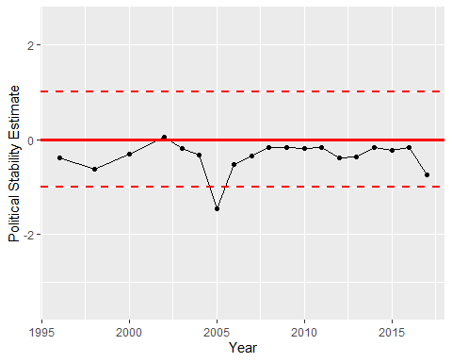

Political Stability Trend